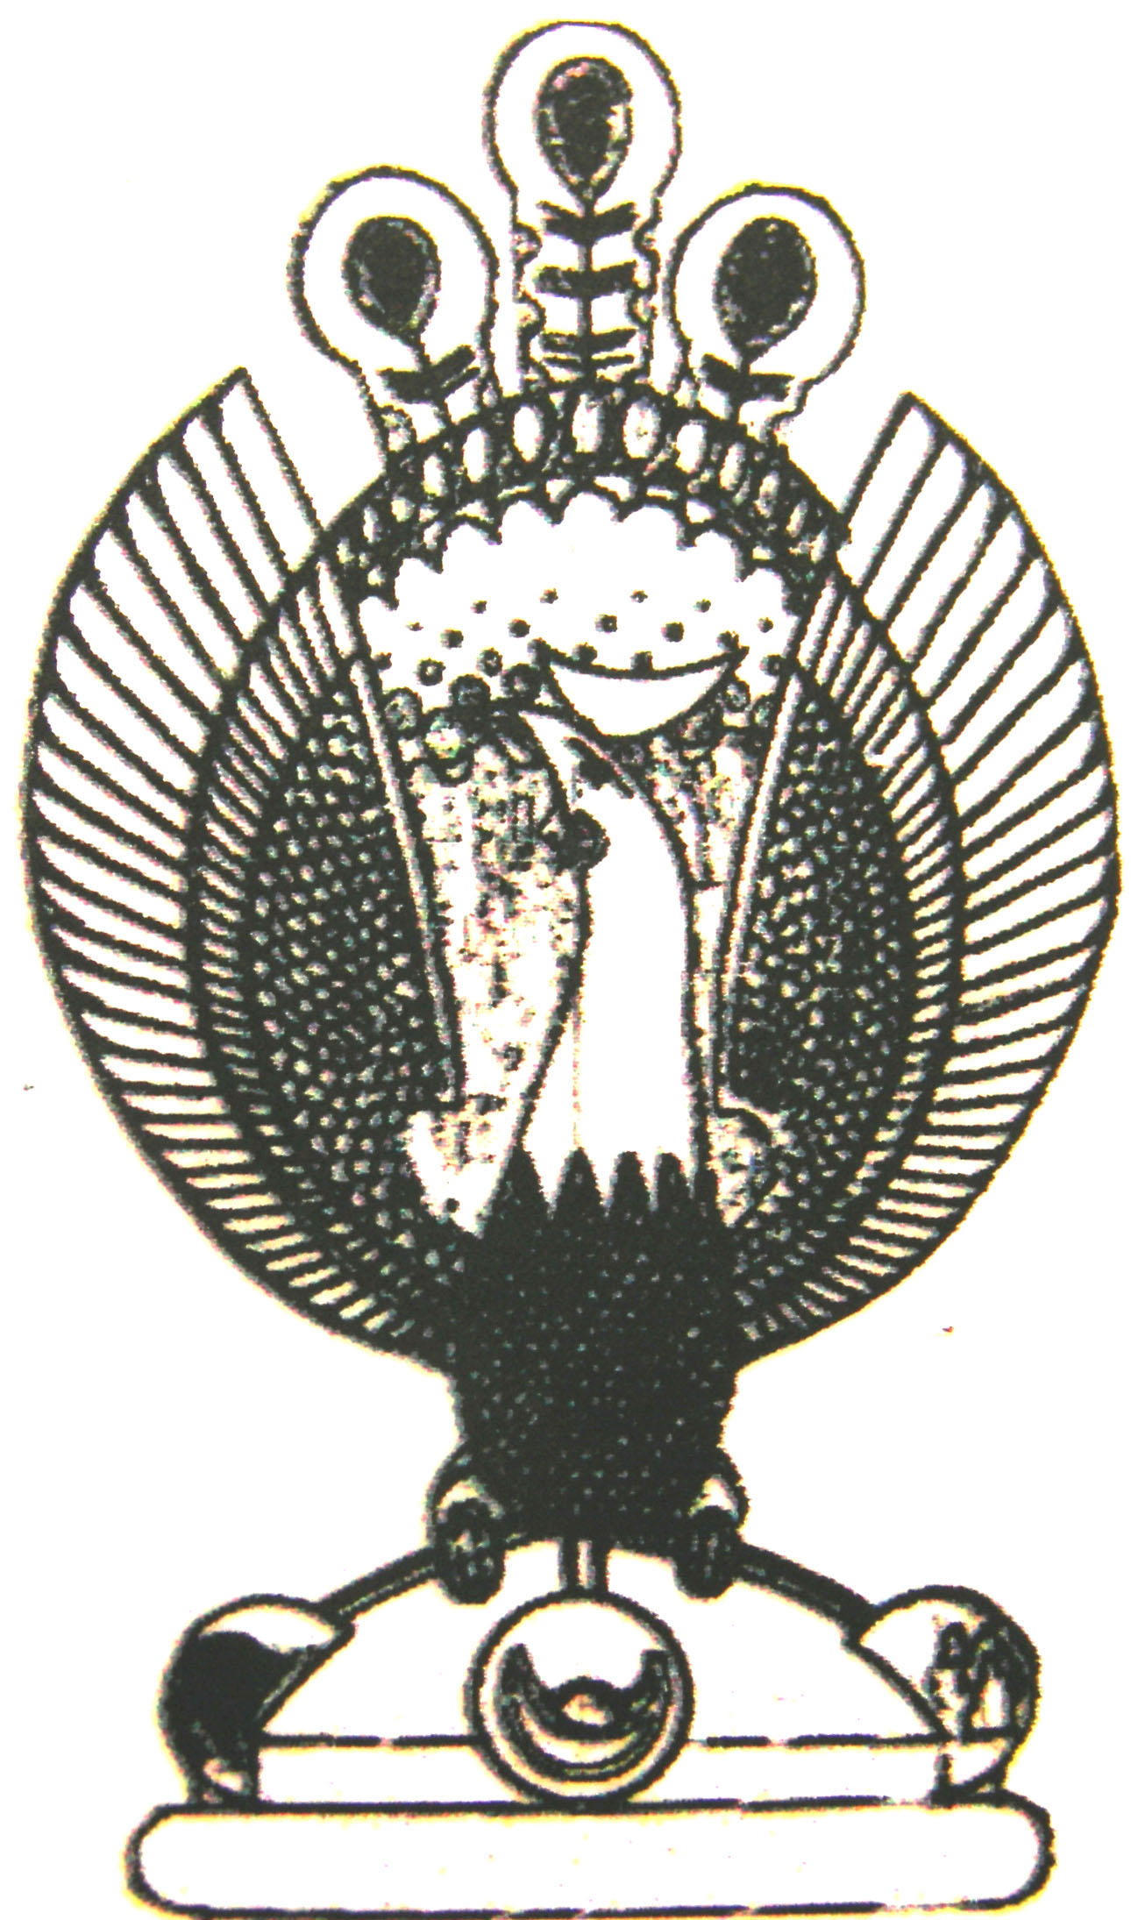

THE HERITAGE

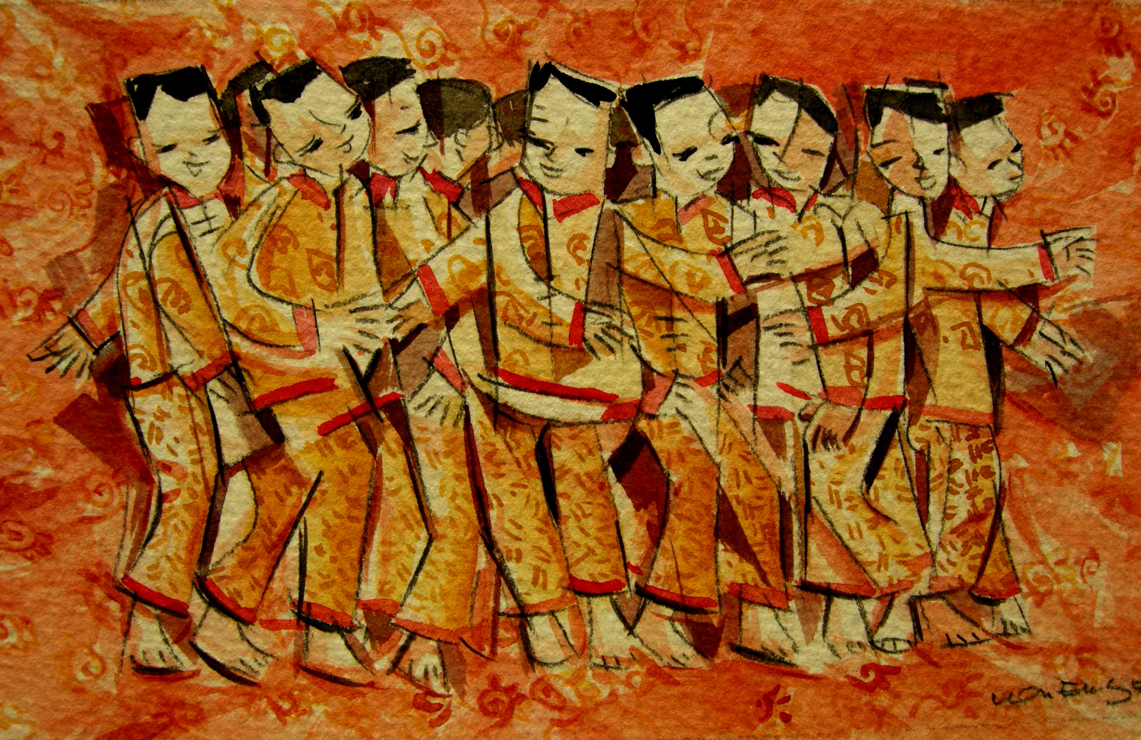
‘An Chng’
During the ‘an chng’ ceremony, a teenaged boy born in the year of the dragon is asked to roll back and forth three times across the bed in his best clothes as a blessing for a first-born male child. He should come from a large family with both parents still alive. He receives a red packet and two red candles for the service.

